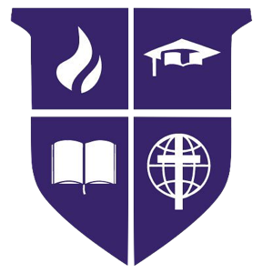

KELOWNA CHRISTIAN SCHOOL
Job Posting – April 27, 2022

Located in the sunny Okanagan Valley, Kelowna Christian School is the largest independent Christian school in the city of Kelowna, British Columbia, educating approximately 800 students from Preschool to Grade 12 on two campuses.

Founded in 1978, Kelowna Christian School exists to educate, equip and inspire our school community to become disciples of Jesus who love and serve God and others.

We are currently accepting applications for the following teacher position:

- Grade 5 - Full time

We are seeking a dynamic, collaborative BC certified Christian educator who demonstrates a commitment towards Christian Education. The successful candiate will have the ability to deliver curriculum content in an innovative manner that fully engages students in learning, and acts as a personal model to deepen students’ understanding of a Biblical worldview and relationship with God. The successful candidate will also be able to work in a highly collaborative team environment and be able to provide differentiated programming.

The closing date for this posting is Thursday, May 13th or until the position is filled.

Please see the school website (www.kcschool.ca/about-us/career-opportunities) for the full application form and details of the application process. Applications will be kept on file for two years. The school will contact only those applicants short-listed for a specifically posted position or Teacher on Call position.

Electronic submission of applications and supporting documentation should be sent to:

- Mike Campbell, Head of School
- Kelowna Christian School
- Email: applications@kcschool.ca

